JUNEAU ARTS & HUMANITIES COUNCIL PRESENTS

**WEARABLE ART 2026: *CAMP!***

CELEBRATING 24 YEARS OF WEARABLE ART IN JUNEAU!

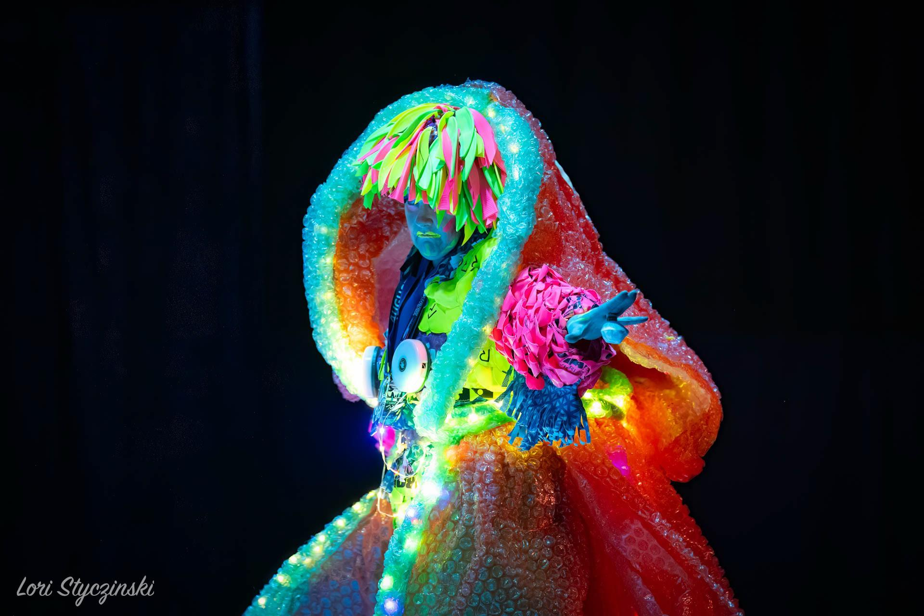



ARTIST & MODEL PACKET

**Questions?**

[wearableart@jahc.org](mailto:wearableart@jahc.org)

**Margeaux Ljungberg Wearable Art Director** [margeauxljungberg@gmail.com](mailto:margeauxljungberg@gmail.com)

**Kathleen Harper Technical Producer** [kathleen@Jahc.org](mailto:kathleen@Jahc.org)

Welcome to Juneau’s 24th Wearable Art Extravaganza!

Welcome, and thank you for joining this group of incredible people who bring Wearable Art to Juneau. Together, we have been creating fabulous works of wearable art for the past **24 years**! The original organizers began this event as a grassroots, community-based gathering. Over the years, Wearable Art has evolved, but the mission has always remained the same: Create, foster, and inspire diverse forms of creativity in our community.

For Artists, Wearable Art is an opportunity to explore, experiment, and showcase their talent through creating a piece to be worn and modeled on the runway. For Audiences, it is a joyful, enriching, and invigorating entertainment that brings friends and family together in a celebration of community creativity. For the Juneau Arts & Humanities Council, it is a fundraising event that supports their many programs and workshops, speciﬁcally the operation of the JACC, and the grants & scholarships that beneﬁt our emerging artists and youth. For all of Juneau, it is a tangible enactment of the Council’s core values of community, equity, and stewardship.

This packet contains information for you to refer to throughout your creative process, including:

* A calendar of deadlines & important dates
* Creative process, registration, and technical requirements for 2026 entries
* F.A.Q.s for new Artists & Models
* An Artist / Model Agreement to be signed & submitted to the JAHC
* A Liability Waiver & Media Release to be signed & submitted to the JAHC

Artist & Models - GUNALCHÉESH, THANK YOU - for your incredible talent, resources, time, and creativity to make Wearable Art such an unbelievably successful and enjoyable event. Juneau continues to place on a researched list of the 10 Most Culturally Vibrant Small Arts Communities in the United States. This event is at the forefront of that vibrancy –it truly wouldn’t be possible without your imagination and willpower.

We hope you ﬁnd this packet informative and helpful. Our staﬀ are here to support and guide you in being an invaluable and successful member of this many-faceted event. Please don’t hesitate to contact us with questions or concerns.

Gunalchéesh,



Stacy Katasse

Interim Director, Juneau Arts & Humanities Council

## Wearable Art 2026 Checklist & Due Dates

**November 17, 2025 - 11:59pm - REGISTRATION DEADLINE**

Artist Registrations due, including:

* Online Application, all questions **fully answered**
* Signed Agreement pages, for both Artist & Model
* Signed Liability Waivers, for both Artist & Model
* Signed Media Release, for both Artist & Model
* Registration Fee Paid (invoiced via email)

**DEC 2 - WELCOME PARTY & ORIENTATION**

Optional but it will be a fun party and a chance to meet everyone! All artists, models, and production team members are invited to attend.

**DEC 8, 9, 11 - INTERVIEWS, VARYING TIMES**

Artist & Model Interviews

* Artist attendance required
* Model attendance required
* 20 Min slots - we will chat about:

❏ Music choice preferences

❏ Piece size, movement, and aesthetic

❏ General mood & lighting

❏ Special Needs / Restriction

**DEC 19 - MUSIC DECISIONS & DRAFT PROGRAM INFO DUE**

Artist Music decisions due.

* Any discussions on song choice between Director & Artist are wrapped up.
* Music cut requests are submitted to Sound Engineer.

**DEC 29 - FINAL MUSIC CUT CONFIRMED**

**JAN 4, 5, 6 - MODEL REHEARSALS, Centennial Hall VARYING TIMES**

REQUIRED: WEEK 1 Model Rehearsals (Centennial Hall) Full runway tapped out on floor

* Model attendance required
* Artist attendance encouraged

**JAN 13, 14, 15 - MODEL REHEARSALS, JAHC - VARYING TIMES**

OPTIONAL: WEEK 2 Model Rehearsals (JACC)

**JAN 15 - FINAL PROGRAM INFO DUE**

**FEB 8** - **GRAND PARADE, 5-9pm - Centennial Hall**

Grand Parade Rehearsal

* Model attendance required
* Artist attendance encouraged
* Full pieces must be worn

**FEB 12, 13 - TECH REHEARSALS, VARYING TIMES**

“Move-In” days. Dressing room sign ups to be posted

week before.

Thurs Feb 12: Tech Act 1, Centennial Hall

* Model attendance required
* Artist attendance required
* Models must wear the entire Wearable Art piece or have it ready to show the production team.
* Hair & make up highly encouraged

Friday Feb 13: Tech Act 2, Centennial Hall

* Model attendance required
* Artist attendance required
* Models must wear the entire Wearable Art piece or have it ready to show the production team.
* Hair & make up highly encouraged

**FEB 14, 15 - DRESS REHEARSAL 12-4pm, SAT PERFORMANCE 8pm, SUN PERFORMANCE 3pm**

Saturday Dress Rehearsal: 12:00-4:00pm, Centennial Hall

* Model attendance required
* Artist attendance required
* All pieces must be ﬁnished for the dress rehearsal
* Full hair & make up must be worn
* Call times to be posted week of the show

Saturday Performance: 8:00pm, Centennial Hall

* Model attendance required
* Artist attendance required
* Full pieces must be worn
* Full hair & make up must be worn
* Call times to be posted week of the show

Sunday Performance: 3:00pm, Centennial Hall

* Model attendance required
* Artist attendance required
* Full pieces must be worn
* Full hair & make up must be worn
* Call times to be posted week of the show

## Creative Process Requirements

*The Director & Production Team have the following requests for artists as they craft their pieces, narratives,*

*music, and choreography for the runway.*

### Theme: “CAMP!”

Please refer to the theme in your written & spoken narratives in some manner. You may refer to any speciﬁc synonyms or analogous phrases. This is not intended to be restricting, but to help push boundaries, and provide links and/or bridges between acts.

### Originality

Art, in its essence, can be deﬁned as a visual or physical expression of the human experience. We recognize that inspiration comes from all around us - our environment, our friends, and even works done by other artists. We request that your work is an original creation, complying with copyright and trademark guidelines, and does not infringe on intellectual property rights. This can be diﬃcult to deﬁne, so we oﬀer a percentage rule-of-thumb: **at least 85%** of your piece must be your own design. A quick Google Image or Pinterest search using keywords describing your piece, or elements of, may be a good way to ensure your originality. If you are concerned or confused about where your piece stands in relation to this rule, we recommend you reach out to the Director and the Artist Representatives. The Wearable Art team is welcoming, constructive, and happy to communicate with you.

The JAHC Board of Directors and Staﬀ have enacted an equity and inclusion policy to guide JAHC programming, events and actions. During the development of this policy there have been many conversations about racial inequity, cultural appropriation and unintentional exclusion and stereotyping. And, we are conﬁdent and hopeful these conversations will continue. Please review the equity and inclusion policy on the next page, and keep it in mind as you design and create your project. If you have questions or concerns please don't hesitate to call us. The Board and Staﬀ will be available to listen, support and oﬀer suggestions to ensure success during the creative process and performance for both the artists and the audience.

# JAHC STATEMENT ON RACIAL EQUITY

The Juneau Arts and Humanities Council in all matters related to employees, board members, committee and task force members, and volunteers is guided by a set of principles and goals for our organization and our community. With this Equity Statement, the JAHC reaﬃrms our commitment to racial equity, which includes the elimination of policies, practices, attitudes and cultural messages that reinforce diﬀerential outcomes by race. We commit to working to increase arts opportunities for people of the global majority.

**ACKNOWLEDGEMENTS & AFFIRMATIONS**

All peoples, their cultures, and their art contribute to the meaning and understanding of our humanity and should be honored and celebrated.

In the United States, there are systems of power and privilege that create inequity and injustice and must be continuously addressed and changed. Artists, their art, their process, and the organizations they create and support play a unique role in witnessing, demonstrating, and providing inspiration to resolve societal inequity and injustice. We, the Board of Trustees and the staﬀ of the JAHC, must all hold ourselves accountable, because acknowledging and challenging societal inequities and internal biases and working in partnership with our community is how we will make change happen.

**MODELING THROUGH ACTION FOR RACIAL EQUITY**

To provide informed, authentic leadership throughout our organization we strive to:

* Pursue cultural awareness through ongoing substantive learning, transparent policies, and restorative justice practices.
* Commit time and resources to acknowledge and dismantle systems of inequity within our organization and communicate ongoing action to our constituency.
* Commit time and resources to foster more diverse leadership within our board, staﬀ, and advisory bodies.
* Commit time and resources to expand support for more diverse Southeast Alaska arts organizations.
* Commit time and resources to expand the diversity of, and access to, our programming.

**RACIAL EQUITY, INTERSECTIONALITY, AND RADICAL SUPPORT**

The JAHC recognizes that our society is challenged to overcome a complex web of inequities – racism, sexism, homophobia, classism, and ableism among them. While this statement has been intentionally focused on racial equity, we aﬃrm that the JAHC is [intersectional](https://www.intersectionaljustice.org/what-is-intersectionality) in our thought, practices, and actions. To create antiracist practices, we commit to providing radical support to all historically marginalized members of our constituency. The JAHC holds a position of privilege in our community, and we strive to use this position to elevate others.

## Registration & Eligibility Requirements

### Number of Models Per Piece

Each piece may register for up to **3** models, without prior consent from the Director. If creative vision entails more than 3 models, for either a portion or the entire 2 minutes of your act, you must communicate with the Director prior to the registration deadline, and gain written consent (yes, email counts).

### Music & Runway Time

* **Time:** Each piece is allotted **2:07 minutes.**

**Audio Files** : You will submit 3 song choices in your application form, listed in priority (1st, 2nd, 3rd.) In the event that 2 artists choose the same song, the Director will defer to the registration submitted with the earlier time stamp. The Director may also provide feedback on additional inspiration for your song choice, and in some cases may request or suggest diﬀerent music.

The Director will approve your song after working with JAHC staﬀ to make sure that we are able to obtain the music licensing rights for a public performance. If your top choice isn’t available, the Director will resume discussing one of your other choices. Part of your registration fee will go towards purchasing the music and rights for your performance. The fee will cover up to $10 in cost. A discussion can happen if you want to cover any additional costs.

After song approval, our audio engineer will purchase your music and make any necessary cuts (this may require an in-person meeting with her in her studio at the JACC). Prior to the first

rehearsal the final cut version of your song will be emailed to you. Artists must listen to their music and confirm their cut via email before December 29th.

### Sketch & Mood Board

* **Sketch / Photo:** Please upload a sketch of your planned piece. If you have already begun to work on it, you may also upload photos. The more we know about your piece, the better we can plan for lighting, video, and stage managing!
* **Mood Board -** In addition to your sketch, the production team would appreciate some type of visual and/or verbal representation of your inspiration and aesthetic. It can be, but is not limited to: a collage, reference photos, color palettes, descriptive adjectives or verbs, additional sketches, thought trains or mind maps, or more.

## Technical, Rehearsal & Performance Requirements

### Artist Interview Expectations

Up until interviews, we will just be communicating over email or phone. The artist & model interviews give all of us a chance to meet in person or over zoom, for you to tell us more about your vision, and for us to double check a few logistical things. The production team will have a few standard questions for you (below), and you’ll have a chance to ask us questions too! **Both Artists & Models are required to attend**. Things we will go over:

* Discuss music options
* Conﬁrm Model attendance at 1 individual rehearsal, grand parade rehearsal, tech rehearsal / dress rehearsal / performances.
* Chat about:
  + Overall mood / aesthetic / story of your piece
  + Will you be shedding any layers / materials?
  + Lighting requests
  + Choreography ideas
  + Other questions / concerns

### Rehearsal Expectations & Requirements

Individual Model rehearsals begin in January and are an integral part of the Wearable Art process. Models are required to attend *at least one* rehearsal week in person . Artists are highly encouraged to attend, in order to participate in choreography discussions with the Director, and watch /adjust how pieces move and function on the runway. The Director, Producer, Stage Manager, and additional Model Coaches will be present at rehearsal. The Director will begin to work with models & artists on their movement down the runway. During your 30-minute rehearsal, the Model will spend the ﬁrst 15 minutes working on over-all choreography & movement with the Director, and the second 15 minutes working with a Model Coach to reﬁne their movements. Models are required to attend - artists are encouraged to attend to help be part of the choreography process.

##### Please bring with you any / all completed parts of your piece. In particular we highly suggest, even if not ﬁnished:

* + **Footwear** (practice in heels if you will wear heels! Practice barefoot if you will be barefoot).
  + Any **large elements** you need to practice maneuvering - hoop skirts, long trains, wings, tails, headpieces, jackets that you will shed, internal lighting that needs to be timed, etc. Stand-in props are helpful too - i.e. if your jacket has paint drying on it, bring a shawl to mime with. If your mermaid skirt that constricts your footsteps is on the sewing counter, bring a band to put around your ankles that has the same opening.

#### Runway Entrances

Depending on the ﬁnal set design, the Director may require all models to enter from the same side of the runway. If you feel this inhibits your piece and choreography, please submit an alternative entrance plan to the Director before ﬁrst rehearsal.

#### Narratives

Written and Spoken Narratives are no longer included in the Artist Registrations. The team will reach out to registered artists in December to get text for these items with a ﬁnal review due by January 15.

* **Written Narrative:** A short and sweet description for print in the program, including: 1) Piece Title, 2) Artist Name(s), 3) Model Name(s), 4) Materials List, 5) Acknowledgments or Dedications (acknowledgments limited to 80 words).
* **Spoken Narrative**: The introductory speech the MCs read before your piece walks the runway There will be many opportunities for revision. Spoken narratives must not exceed 5 sentences. Note that the Director and MCs will edit narratives slightly for ﬂow, dynamics, and voice, with collaboration and input from the artist. All narratives that exceed 5 sentences will be edited to 5 sentences.
  + Need specialized language speakers? We’re happy to work towards solutions. Please let us know ASAP so we can start conversations and collaborations.

#### Grand Parade Rehearsal Requirements

Grand Parade is the show ﬁnale, with all the models walking the runway one more time, in show order, to lively music. As each model steps onto the runway, the artist photo appears on the screen, giving the audience a chance to see the creator behind the art. The models walk the entire runway (quickly), and exit. At Grand Parade rehearsal, the Director will coach the models with basic but timed choreography - models walking quickly, short poses, one after the other. **ATTENDANCE AT GRAND PARADE REHEARSAL FOR ALL PARTICIPATING MODELS IS REQUIRED. Failure to attend Grand Parade Rehearsal disqualiﬁes your model from Grand Parade during the Performances.**

### Tech & Dress Rehearsal Requirements

Tech Rehearsal is the ﬁrst time Models will be on the real runway, and the production crew gets to see the full eﬀect of the Artists’ hard work! It’s a very exciting time for everyone. Models will walk the runway, but there will be many stops and pauses as the production team adjusts lights, sound, etc. Dress Rehearsal is the ﬁrst time the show runs top to bottom, with no breaks or adjustments. Tech and Dress are closed to the public, but participating artists and models can watch and support each other during this time. **Treat it like the real deal! ATTENDANCE AT TECH & DRESS REHEARSAL FOR ALL PARTICIPATING MODELS & ARTISTS IS REQUIRED. Failure to participate in tech and dress rehearsal**

##### excludes your piece from the Performances.

* **TECH REHEARSAL** - **Full Dress is required** - all pieces of the garment must be on, Full Make Up is strongly encouraged. Act 1 techs on Thursday, Act 2 on Friday. You won’t know what act you are in until about 2 weeks out from the show.
* **DRESS REHEARSAL - Full Dress AND Full Make Up is required. All pieces must be ﬁnished for the dress rehearsal no matter what.**

### Performance Requirements

IT'S SHOWTIME! Depending on your Act 1 or 2 Assignment, you will have a listed call time. **Artists & Models must be in the building at your dressing station before or by the listed call time. Models must be in full make up, hair, and dress for each Performance.** Backstage Etiquette:

* **You must remain sober and of sound mind and body for each performance**. It’s an exciting night, but we must ensure the safety of the models, artists, crew, and audience. If we suspect you are not sober, you may be disqualiﬁed from the show.
* **Please stay within your dressing room assignment area**. Keep personal belongings, makeup, supplies, and your wearable art piece to your assigned dressing room area. Space in the dressing room is tight and pieces can be extremely large and/or extremely delicate. Be spatially aware, cognizant of your neighbor and the need for other pieces to enter and exit the room (aka don't block the door, please).
* **Backstage is not for family and friends** - you will be allowed 1 backstage helper per piece to assist beyond the artist and/or model.
* **Dressing Room Assistants** are stationed in each room to assist in emergencies, keep an eye on time, and relay any updates to the production team. Consider them your ﬁrst point of contact for helping address any problems or concerns.

## F.A.Qs for New Artists & Models

### Is there a registration fee?

Yes, this year it is $50.

### Do I have to use only recycled materials?

Nope! You can create with whatever you’d like! Be it fabric, yarn, hot glue, paper, gill nets, or moss, this is your chance to use your imagination. However, we recommend a few things to keep everyone safe & happy:

* Consider edges that may poke / rub as your model moves
* Consider the fragility of any delicate materials, and the ease of replacement, if they fall oﬀ / break
* Consider the relationship between up-close & precision details, versus large & dramatic features - what is your goal & how might you best convey it?
* Please refer to the originality clause, and make sure what you’re making is truly unique to your own creation!

### I love glitter. Is it legal?

**Nope!** Glitter, as exciting as it is, NEVER GOES AWAY. Which means *extensive* cleaning of the dressing room chairs & carpets, and a very large bill for the Arts Council. LOOSE GLITTER ON BODIES OR PIECES IS NOT OK. GLITTER SPRAY IS ALSO NOT OK. BUT….

* If it is completely sealed by mod podge, polyurethane, or some other sealant, then it is OK.
* If it’s make-up with a glittery sheen, that is also ok.

If you have any questions or concerns about glitter, just ask! We are here to help.

### Scholarship fund

We know how much time, eﬀort, and resources go into the amazing pieces you create! This is a Wearable Art Materials / Travel Scholarship Fund to help artists with creation costs or out-of-town travel. If you anticipate high expenses, please email the JAHC Programs Manager Rachelle Bonnett at [rachelle@jahc.org,](mailto:rachelle@jahc.org) and inquire about scholarship availability. You can submit a form detailing your need, and the JAHC Staﬀ and an Artist Representative will review and disburse funds on availability.

## F.A.Qs for New Artists & Models cont.

### Do I need to pay for seats?

Yes and no. *Fully registered* artists & their models receive 1 complimentary seat **per team** for Sunday's show for the value of a standard general admission ticket, artists can upgrade if they choose.

### AM I a JAHC Member?

If you aren’t already through a prior donation, you will be! Participating artists & models get JAHC memberships in their Thank You Bags from the Arts Council. It is good for one year from the start date (the week of Wearable Art), and your beneﬁts include 10% oﬀ in the Lobby shop, 10% oﬀ JAHC Concert Tickets, Advance Ticket Purchase for other popular fundraisers (such as Art Glasses, Clink!, and more), and General Feel Good-ness knowing you’ve helped support innumerable arts & culture opportunities in our community!

Sketching Template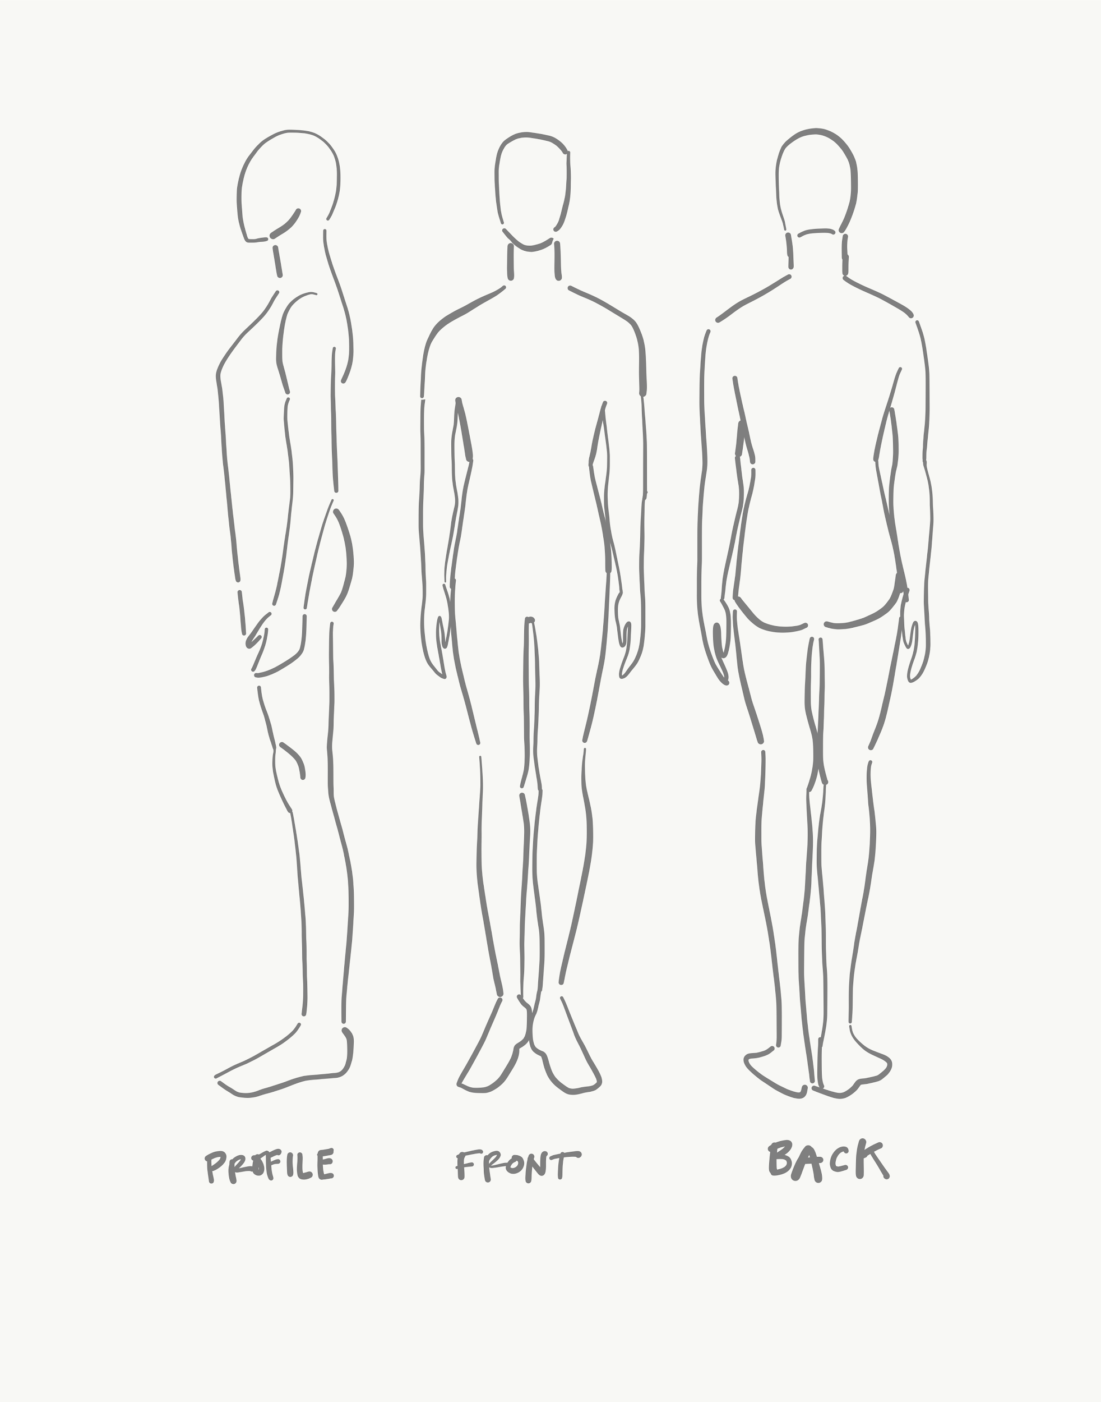

# JAHC LIABILITY WAIVER & HOLD HARMLESS AGREEMENT

1. In consideration for receiving permission to participate in **Wearable Art**, I hereby RELEASE, WAIVE, DISCHARGE AND COVENANT NOT TO SUE Juneau Arts & Humanities Council, their oﬃcers, servants, agents, or employees (hereinafter referred to as RELEASEES) from any and all liability, claims, demands, action and causes of action whatsoever arising out of or related to any loss, damage, or injury, including death, that may be sustained by me, or to any property belonging to me, WHETHER CAUSED BY THE NEGLIGENCE OF THE RELEASEES, or otherwise, while participating in such activity, or while in, on or upon the premises where the activity is being conducted.
2. I hereby elect to voluntarily participate in said activity, and to enter the above-named premises and engage in such activity knowing that certain risk of harm are or may be inherent in the various activities contemplated herein and that the activity may be hazardous to me and my property. I VOLUNTARILY ASSUME FULL RESPONSIBILITY FOR ANY RISKS OF LOSS, PROPERTY DAMAGE OR PERSONAL INJURY, INCLUDING DEATH, that may

be sustained by me, or any loss or damage to property owned by me, as a result of being engaged in such an activity, WHETHER CAUSED BY THE NEGLIGENCE OF RELEASEES or otherwise.

1. I further hereby AGREE TO INDEMNIFY AND HOLD HARMLESS the RELEASEES from any loss, liability, damage or costs, including court cost and attorney's fees, that they may incur due to my participation in said activity, WHETHER CAUSED BY OR CONTRIBUTED TO IN WHOLE OR PART by any action or failure to act, negligence, breach of contract, or other misconduct on the part of RELEASEES or otherwise.
2. It is my express intent that this Release and Hold Harmless Agreement shall bind the members of my family and spouse, if I am alive, and my heirs, assigns and personal representative, if I am deceased, and shall be deemed as a RELEASE, WAIVER, DISCHARGE AND COVENANT NOT TO SUE the above named RELEASEES. I hereby further agree that this Waiver of Liability and Hold Harmless Agreement shall be construed in accordance with the laws of the State of Alaska.

IN SIGNING THIS RELEASE, I ACKNOWLEDGE AND REPRESENT THAT I have read the foregoing Waiver of Liability and Hold Harmless Agreement, understand it and sign it voluntarily as my own free act and deed; no oral representations, statements, or inducements, apart from the foregoing written agreement, have been made; I am at least eighteen (18) years of age and fully competent; and I execute the Release For full, adequate, and complete consideration fully intending to be bound by same.



*Signature Print Name Date*



*If Minor (U18yo): Parent/Guardian Signature & Print Name*

*If Minor: DOB*

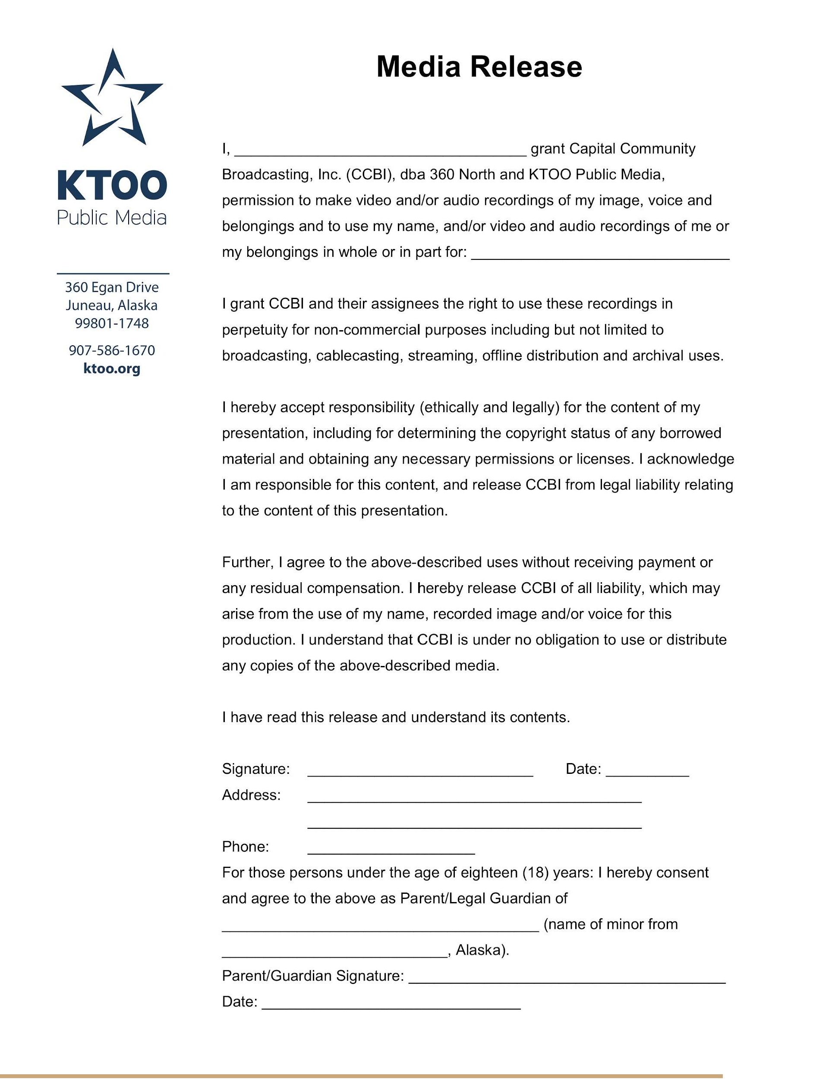

# ARTIST & MODEL AGREEMENT PAGE

##### PLEASE READ, SIGN, AND REPEAT FOR AS MANY ARE NECESSARY ON YOUR TEAM.

I, or my Artist & Model team, has read and understands the creative process & registration requirements, and the proposed rehearsal, tech, dress, and performance schedule, and I understand that slight schedule changes may occur. Repeat signatures as needed per your team members.

Artist Model 

*Signature Circle One Above Date*

Artist Model 

*Signature Circle One Above Date*

Artist Model 

*Signature Circle One Above Date*

Artist Model 

*Signature Circle One Above Date*

Artist Model 

*Signature Circle One Above Date*

Artist Model 

*Signature Circle One Above Date*